Sample Data
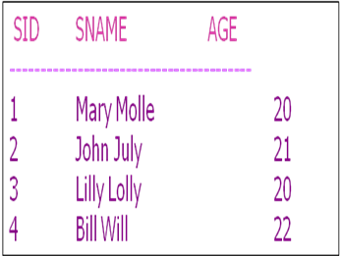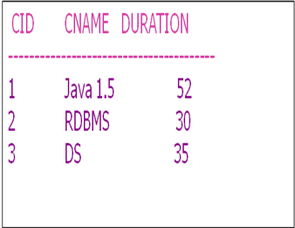
- Create tables (Student & Course)
- Insert values into tables
- Find the ids and names of all students.
- Get all the details of the courses whose duration is more than 50 hours.
- Find sid of Bill Will.
- For number of 7-hour day it will take to finish the individual courses.
- Retrieve studentid and name with the alias Roll No and First Name.
- Find all the students who name end with the letter ‘y’.
- Find all the enrollments that happened in july.
- Find the 2 lettered course name that ends with a ‘S’
- Find all the students whose name as two characters before ‘ll’.
- Find all courses in the range of 30 to 35 hours.
- Get all the student’s name whose sids are 2 and 4.
- Get all the student’s name whose sids are not in 2 or 3.
- Select all students details whose age is greater than 20.
- Update sname as Mary Charly whose SID is 1

